



**CERTIFICATE**

This is to certify that the report entitled **“Stock Prediction”** is a bonafide work carried out by **Mr. Ishan Trivedi (16IT140) & Mr. Raj Vasani (16IT142)** under the guidance and supervision of **Prof. Ravi Patel** for the subject **Software Group Project-2 (IT345)** of **5th**  emester of Bachelor of Technology in **Information Technology** at Faculty of Technology & Engineering – CHARUSAT, Gujarat.

To the best of my knowledge and belief, this work embodies the work of candidate themselves , have duly been completed, and fulfills the requirement of the ordinance relating to the B.Tech. Degree of the University and is up to the standard in respect of content, presentation and language for being referred to the examiner.

|  |
| --- |
| Under supervision of,  **Prof. Ravi Patel**  Assistant Professor  Dept. of Information Technology  CSPIT, Changa, Gujarat. |
| **Prof. Parth Shah**  Head & Associate Professor  Department of Information Technology  CSPIT, Changa, Gujarat. |

**Chandubhai S Patel Institute of Technology**

At: Changa, Ta. Petlad, Dist. Anand, PIN: 388 421. Gujarat

**TABLE OF CONTENTS**

**Acknowledgement 4**

**Abstract 5**

**Chapter 1 Introduction 7**

1.1 Project Summary 7

1.1.1 Purpose….……………………………………………………………………...7

1.2 Scope 7

1.3 Objective 7

**Chapter 2 System Requirements Study 8**

2.1 Tools & Technology Used 8

**Chapter 3 System Design 9**

3.1 Project Flow 9

**Chapter 4 Implementation Planning 10**

4.1 Code 10

4.2 Snapshots of project 13

**Chapter 5 Limitations and Future Enhancement 15**

**Chapter 6 Conclusion 16**

**References 17**

**ACKNOWLEDGEMENT**

We have found this rare opportunity to evince a word of thanks to all those who played a key role in the successful completion of our project. We are thankful to our Head of Department **Prof. Parth Shah** Sir for giving the chance as well as support for all the time being. And his able guidance and continuous encouragement made us work in all the challenges during project development.

We express deep gratitude to **Mr. Ravi Patel**, assistant professor and internal project guide from Faculty of Engineering, CHARUSAT for their valuable suggestions, help and moral support. Finally, most of all, we thank our family members for their unconditional love, encouragement and support to complete our project work.

We also thank to all those who could not find a separate name but have helped directly and indirectly.

**Abstract**

We analyzed the possibility of predicting stock prices on a short-term, day-to-day basis with help of machine learning by studying the important stocks of Google. Machine Learning is a great way to predict things and study datasets. Python language is used for the coding of this project. Python is better than many other languages for machine learning. This project can help many stock buyers for their day to day trading.

**LIST OF FIGURES**

* **Fig 3.1 Project Flow……………………………………9**
* **Fig 4.2.1 Snapshots of Project…………………………...13**
* **Fig 4.2.2 Snapshots of Project…………………………...13**
* **Fig 4.2.3 Snapshots of Project…………………………...14**
* **Fig 4.2.4 Snapshots of Project…………………………...14**

**Chapter 1: Introduction**

* 1. **Project Summary**

**●** In this application, we are trying to predict the stocks with machine learning. Support Vector Machine Algorithm is used to generate the graph and predict the stock price for a particular date.

**1.1.1 Purpose**

* Our purpose is to provide the rough idea to stock traders about how the stock price will go.
  1. **Scope**

● In this application we have focussed on smaller datasets. We can make this more accurate by taking large datasets.

* 1. **Objective**
* Our objective is to learn about machine learning, python and stock trading.

**Chapter 2: System Requirements Study**

**2.2 Tools & Technology Used**

* Atom for coding in python.
* Matlab Libraries.

**Chapter 3: System Design**

* 1. **Project Flow**

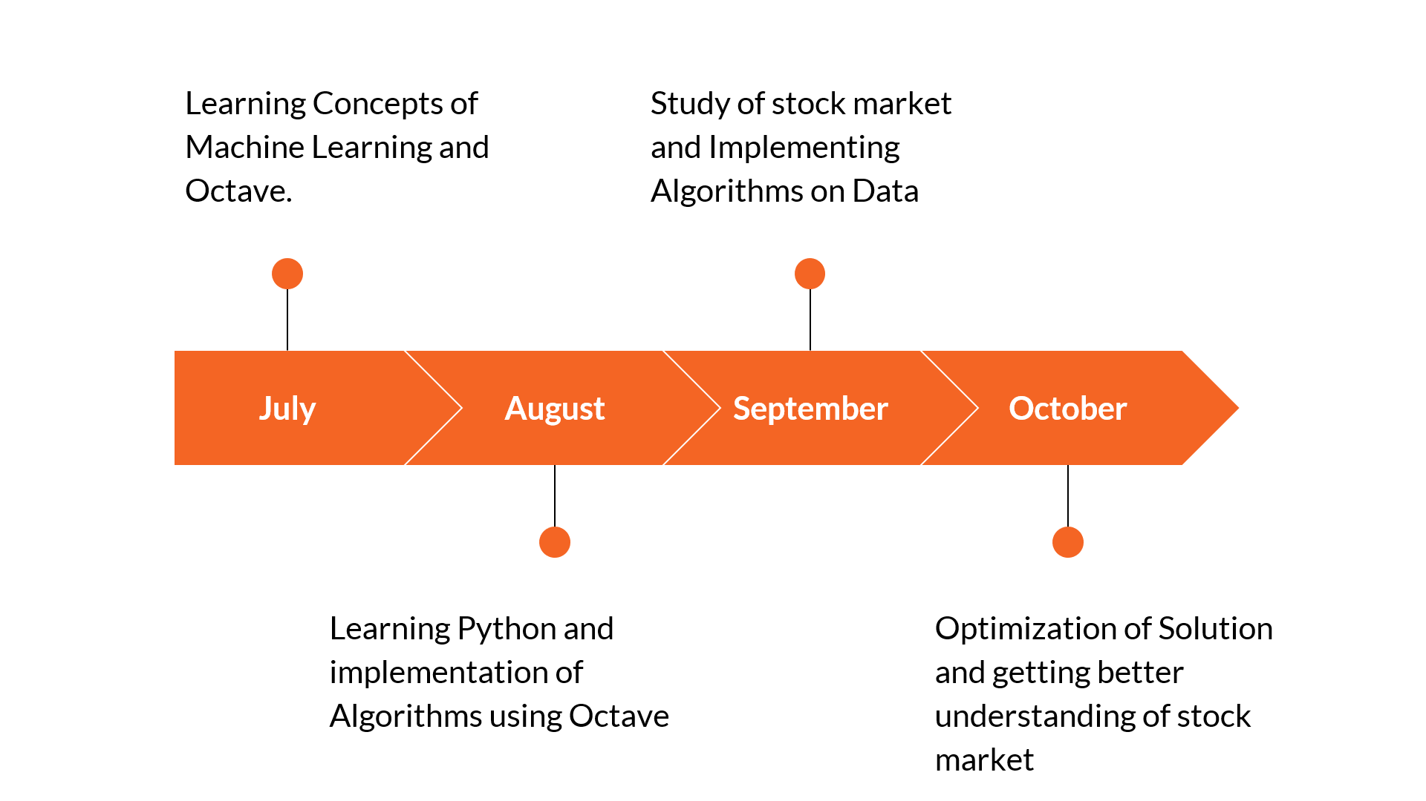

**Chapter 4 Implementation Planning**

**4.1 Code**

* Linear.py

|  |
| --- |
| import csv  import numpy as np  from sklearn import linear_model  import matplotlib.pyplot as plt  dates = []  prices = []  def get_data(filename):  with open(filename, 'r') as csvfile:  csvFileReader = csv.reader(csvfile)  next(csvFileReader) # skipping column names  for row in csvFileReader:  dates.append(int(row[0].split('-')[0]))  prices.append(float(row[1]))  return  def predict_price(dates, prices, x):  dates = np.reshape(dates, (len(dates),1)) # converting to matrix of n X 1  prices = np.reshape(prices, (len(prices),1))  linear_mod = linear_model.LinearRegression() # defining the linear regression model  linear_mod.fit(dates, prices) # fitting the data points in the model  plt.scatter(dates, prices, color= 'black', label= 'Data') # plotting the initial datapoints  plt.plot(dates, linear_mod.predict(dates), color= 'red', label= 'Linear model') # plotting the line made by linear regression  plt.xlabel('Date')  plt.ylabel('Price')  plt.title('Linear Regression')  plt.legend()  plt.show()  return linear_mod.predict(x)[0][0], linear_mod.coef_[0][0], linear_mod.intercept_[0]  get_data('goog.csv') # calling get_data method by passing the csv file to it  print ("Dates- ", dates)  print ("Prices- ", prices)  predicted_price, coefficient, constant = predict_price(dates, prices, 29)  print ("\nThe stock open price for 29th Feb is: $", str(predicted_price))  print ("The regression coefficient is ", str(coefficient), ", and the constant is ", str(constant))  print ("the relationship equation between dates and prices is: price = ", str(coefficient), "* date + ", str(constant)) |

* Svr.py

|  |
| --- |
| import csv  import numpy as np  from sklearn.svm import SVR  import matplotlib.pyplot as plt  dates = []  prices = []  def get_data(filename):  with open(filename, 'r') as csvfile:  csvFileReader = csv.reader(csvfile)  next(csvFileReader) # skipping column names  for row in csvFileReader:  dates.append(int(row[0].split('-')[0]))  prices.append(float(row[1]))  return  def predict_price(dates, prices, x):  dates = np.reshape(dates,(len(dates), 1)) # converting to matrix of n X 1  svr_rbf = SVR(kernel= 'rbf', C= 1e3, gamma= 0.1) # defining the support vector regression models  svr_lin = SVR(kernel= 'linear', C= 1e3)  svr_poly = SVR(kernel= 'poly', C= 1e3, degree= 2)  svr_rbf.fit(dates, prices) # fitting the data points in the models  svr_lin.fit(dates, prices)  svr_poly.fit(dates, prices)  plt.scatter(dates, prices, color= 'black', label= 'Data') # plotting the initial datapoints  plt.plot(dates, svr_rbf.predict(dates), color= 'red', label= 'RBF model') # plotting the line made by the RBF kernel  plt.plot(dates,svr_lin.predict(dates), color= 'green', label= 'Linear model') # plotting the line made by linear kernel  plt.plot(dates,svr_poly.predict(dates), color= 'blue', label= 'Polynomial model') # plotting the line made by polynomial kernel  plt.xlabel('Date')  plt.ylabel('Price')  plt.title('Support Vector Regression')  plt.legend()  plt.show()  return svr_rbf.predict(x)[0], svr_lin.predict(x)[0], svr_poly.predict(x)[0]  get_data('goog.csv') # calling get_data method by passing the csv file to it  print ("Dates- ", dates)  print ("Prices- ", prices)  predicted_price = predict_price(dates, prices, 29)  print ("\nThe stock open price for 29th Feb is:")  print ("RBF kernel: $", str(predicted_price[0]))  print ("Linear kernel: $", str(predicted_price[1]))  print ("Polynomial kernel: $", str(predicted_price[2])) |

**4.3 Snapshots of project**

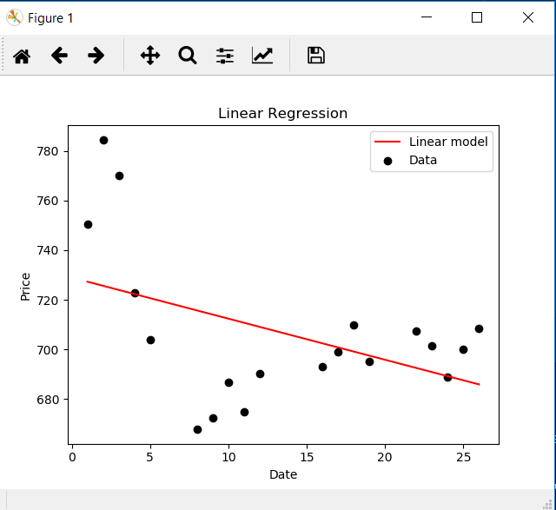

**Fig 4.2.1**

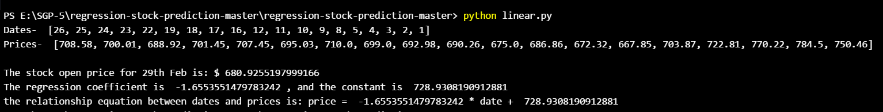

**Fig 4.2.2**

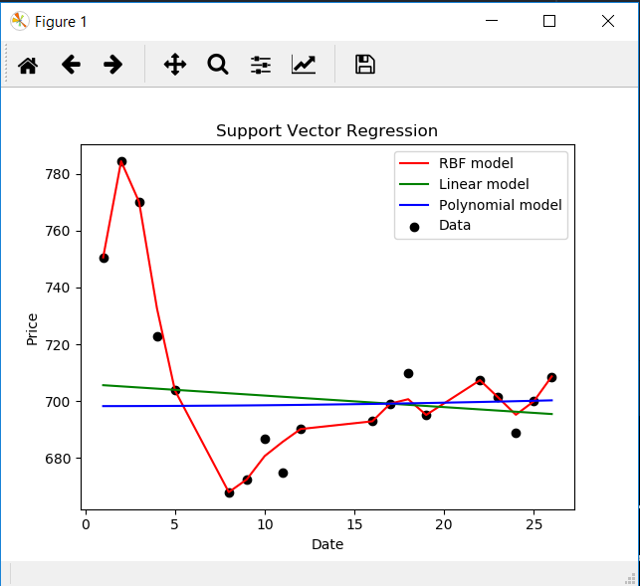

**Fig 4.2.3**

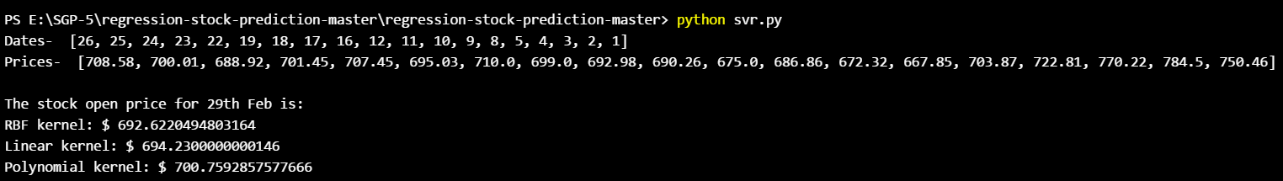

**Fig 4.2.4**

**Chapter 5: Limitations and Future Enhancement**

**5.1 Limitations**

* It is not that much accurate.
* Stock prices can never be predicted.
  1. **Future Enhancement**
* This application is currently not that much accurate but we can extend it by using more larg

**Chapter 6 :Conclusion**

* In this project, we analyzed the possibility of predicting stock prices on a short-term, day-to-day basis with help of machine learning by studying the important stocks of Google. Machine Learning is a great way to predict things and study datasets. Python language is used for the coding of this project. Python is better than many other languages for machine learning. This project can help many stock buyers for their day to day trading.

**References:-**

* [**https://www.coursera.org/learn/machine-learning**](https://www.coursera.org/learn/machine-learning)
* [**https://www.investopedia.com/university/stocks/**](https://www.investopedia.com/university/stocks/)